Jupiter Notebook 2018

Always do “Close and Halt” when exit JN

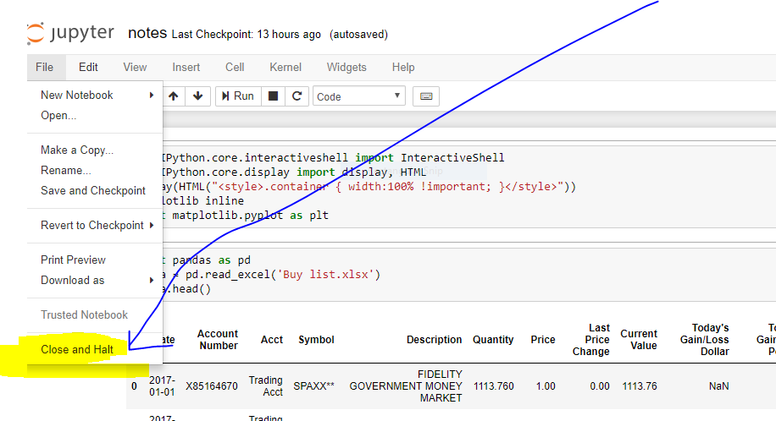

C:\data\jasmin (this directory will get backup)

C:\user\jasmin (Microsoft automatically created) \ project-data (create this virtual directory to point to the above directory)

C:\data\jasmin\blog\ (to Jupiter Notebook directory)

How to create new JN?

Right click JN property, copy a new JN and change directory (at shell) to point to the directory you want

Rename

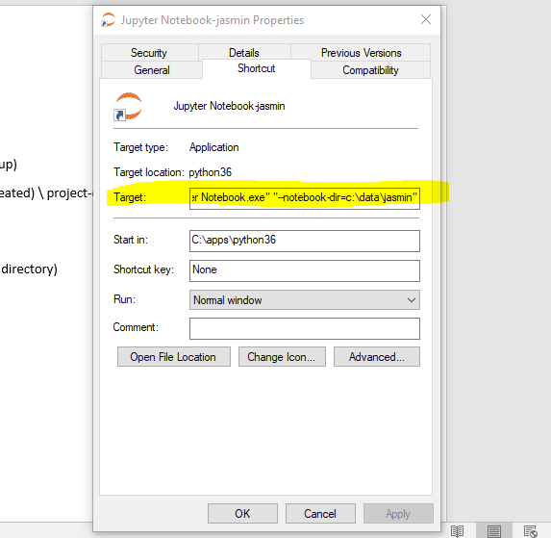

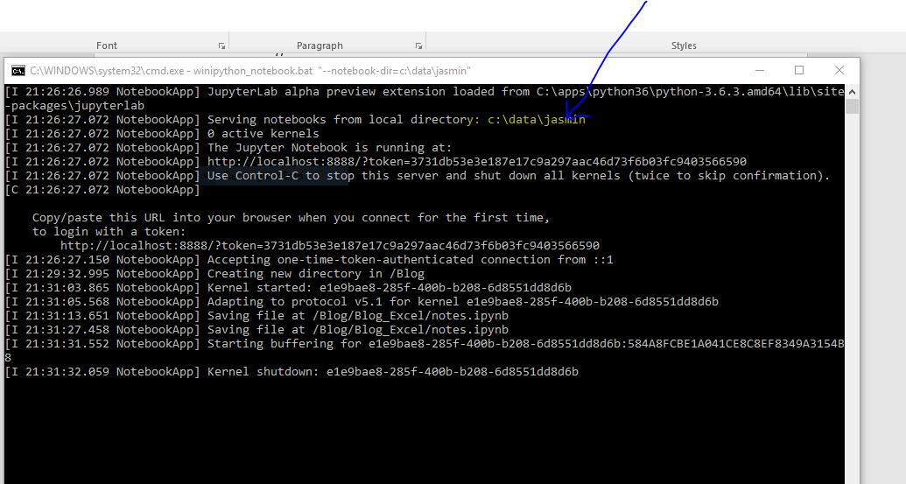

JN

